DAYANAND SHIKSHA SAMITI’S
GHANSHYAM SINGH ARYA KANYA MAHAVIDYALAYA,
ARYA NAGAR, DURG, (C.G.)
B.COM, B.A., DCA, PGDCA, B.ED, M.ED

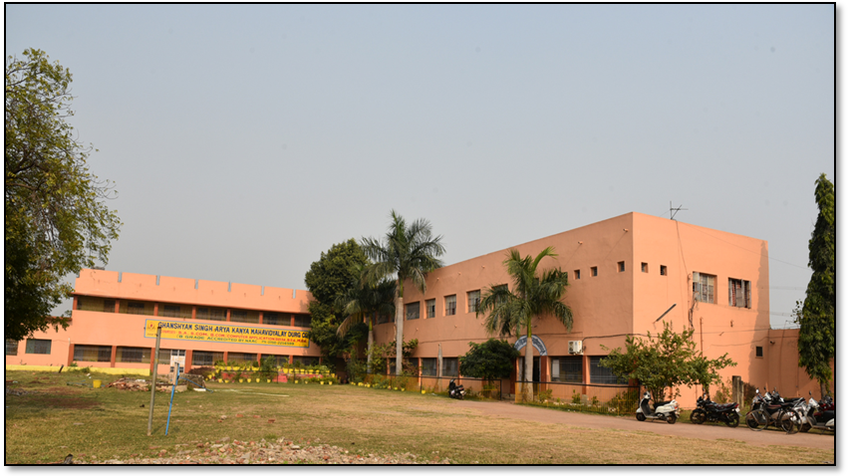

PROFESSIONAL ETHICS AND
CODE OF CONDUCT
BOOKLET

PROFESSIONAL ETHICS AND CODE OF CONDUCT BOOKLET

PREAMBLE

Ghanshyam Singh Arya Kanya Mahavidhyalaya, Durg was established in the year 1978. Thecollege has been actively engaged in the field of education and strives to impart human values and shaping the personality and character of the future citizens of india. In order to sensitise, create awareness about the acceptable norms of workplace behaviour , a standard needs to be set. This policy document will help students to understand social niceties and practice exhibiting good behaviour in institutions of higher learning .
This policy document lays down appropriate rules and regulations to enforce discipline in the campus which will be binding on all the students studying in the college, teachers and administrative/ non teaching staff.

CONTENTS OF THE POLICY DOCUMENT
  - Institutional and professional ethics
  - Code of conduct for students
- Code of conduct for teaching staff
- Code of conduct for administrative/ non teaching staff

DISCLAIMER- the college reserves the right to amend , supplement or modify this code at any time. The college has drafted a separate code which is applicable to students, teaching and non-teaching staff, support and administrative staff.

“CODE OF CONDUCT ”herein after referred to as code is a written policy document which prescribes a set of rules and regulations covering what is appropriate behaviour and acceptable norms in an organisation.

Ethical guidelines are applicable to
- Top Management ( Governing body)
- Principal and Team
- Teachers
- Students/ learners
- Non- teaching and support staff

Areas for Ethical applications-
- Day to day administration
- Teaching – learning-Evaluation
- Professional conduct

I) INSTITUTIONAL AND PROFESSIONAL ETHICS

  - Engage in educational activities inkeeping with the vision and mission of the institution.
  - Set high standards of professional conduct, insist on adherence and compliance of the same
  - Practice open, honest and inclusive communicattion strategies with colleagues
  - Maintain confidentiality in professional relationships and adopt professional approach
  - Be responsible, accountable and fulfill all commitments as promised or agreed upon. Be punctual and report for work on time. Display commitment towards discharging duties with competence .
  - Maintain self- discipline, impartiality and objectivity while dealing with others without any preconceived notions or biases
  - Upgrading professional competencies - upskilling oneself to adapt to the changing educational scenario to deliver quality education
  - Appreciate, acknowledge and encourage merit at all organisational levels.

CODE OF CONDUCT FOR STUDENTS
STATEMENT OF PURPOSE IN DESIGNING A CODE OF CONDUCT FOR STUDENTS-
To create awareness , guide students and encourage them to adopt and imbibe good behavioural norms thereby setting standards of expected and acceptable personal conduct in an educational institution which can act as a road map in the development of ethically sensitive and responsible persons who can positively contribute to the society and nation.

APPLICABILITY

The Code of Conduct for students is mandatory and binding on all students who have enrolled for various UG/PG programme. On taking admission, it is presumed that the student has read and understood the code of conduct and undertake to abide by it non- compliance may be taken by the competent authority as deemed fit .Ignorance of this code of conduct cannot be considered as a sufficient ground to non- compliance.

THE CODE OF CONDUCT FOR STUDENTS HAVE BEEN CLASSIFIED AS

- COC in college premises
- COC in library
- COC in classrooms and practical labs
- COC during examinations

  - IN COLLEGE PREMISES
    - Students are required to wear their Identity card when they enter the college premises and produce it as and when asked for. In case the identity card has been lost/misplaced and not traceable , students are required to get the duplicate I-CARD made .I card should be worn around the neck and must be worn for the entire duration that the student is present in college premises.
    - Students are required to be properly attired and groomed inkeeping with the dignity and decorum of the educational institutional culture and values.
    - Students are required to communicate in a decent and acceptable tone and language with peers, non- teaching and teaching staff. While in the company of peers, use of foul language, expletives and shouting and screaming in lobbies is to be strictly avoided. Students should focus their energies in a constructive manner to learn , develop and enhance skills, competencies, attitudes and values. It is to be noted that violent behavior and reckless yelling will be viewed as a serious case of misconduct hence students are advised to remain calm , maintain their composure and refrain from contributing to the already existing noise pollution.
    - Students are required to enter and leave the college premises in a peaceful manner and avoid overcrowding or group gathering at all times. Students are advised to maintain queue discipline as this will help facilitate easy entry and exit and help control student traffic efficiently .
    - Students are advised to actively participate in co- curricular, extra –curricular activities for their holistic development. Students interested in sport activities, curricular and extra- curricular activities are required to read the details displayed on the notice board and register to participate .
    - Student are advised to behave in a decent manner while in college premises as the entire premises is under CCTV surveillance
    - The college has constituted an Anti-ragging cell as per the directives of the University. Ragging is a serious offence attracting disciplinary action
    - Students are required to read all notices displayed prominently on website and in college premises and keep themselves informed of the various activities and examination dates.
    - At the time of admission, students are required to provide their correct current address, contact no (mobile ) and other details.
    - Help to keep the college premises neat and clean and refrain from littering and spitting
    - Consumption of intoxicants , smoking is strictly prohibited.

  - IN LIBRARY
    - Students are required toput sign in details in themselves at the Entrance.
    - Students are required to maintain silence in the library. No talking/ discussing is allowed . 3)Students are required to comply with all the rules and regulations and follow the instructions given by the librarian /library staff from time to time.
- Students are not allowed to keep their mobile.
- Take good care of books issued to you. Handle with care and return them in a good condition. Do not mutilate the book or tear away pages from the book.

  - IN CLASSROOM–
    - Students are required to follow the class timetable and attend lectures/ practicals as per the time table. Students are required to be present in the classroom /labs on time for the lectures/ practicals.
    - It is the duty of every student to ensure that the conducive atmosphere for teaching- learning is maintained in the classroom.
    - classroom late ,comment on fellow students . Such notorious and disgraceful activities are strongly condemned and discouraged.
    - Students are expected to submit all assignments to the Teacher-in –charge
    - In the classroom, students are required to actively participate in discussions on topics of academic interest and attend all lectures .
    - Students are required to record their attendance for each lecture separately and ensure that the attendance is adequate and above satisfactory levels for each semester seperately. In addition to lectures, the attendance for practicals also needs to be recorded
    - Save electricity by switching off fans and tubelights when not in use. While exiting the classroom, switch off all the fans and tubelights and conserve electricity.
    - Protect all college property from damage. No scribbling on walls, carving on benches or destroying college furniture.
    - All teaching aids, projectors, boards, fixed in certain classrooms are to be carefully handled by students.
    - Discipline is to be maintained in the classroom in the absence of teacher in classroom .Donot disturb the other classes .
    - Computers made available in computer are to be used for academic purposes only.

  - EXAMINATIONS
    - The college has adopted Zero tolerance towards unfair means and cheating in the examination.
    - Students are required to refer to the examination time table and take the examination as per the schedule.
    - Students are required to follow the instructions given by the supervisors / senior supervisors during the examination.

CODE OF CONDUCT FOR TEACHERS
STATEMENT OF PURPOSE IN DESIGNING CODE OF CONDUCT FOR TEACHERS
The code of conduct sets the benchmark of expected behaviour by teachers and underlines mutual respect and regard towards colleagues maintaining professionalism and the dignified status of the teaching profession.

The code of conduct for teachers includes norms during teaching, evaluation and interactions with students , authorities, colleagues and seniors.

- Wear I-card at all times when present in the college.
- Be punctual. Report on time for work – engaging lectures and practicals and for supervision during exams. Engage the lectures and practicals as per the individual timetable allotted
- Record presence by signing attendance register and marking biometric attendance (entry and exit time.
- Complete all teaching work allotted within given time duration. All evaluation and exam related work to be completed within the stipulated time.
- The shared College resources like computers are to be used carefully and judiciously .
- While interacting with students, teachers must endeavor to be objective without any bias or preconceived notions.
- Teachers are not only required to teach but mentor students and guide them in academic areas. This will help build a stronger rapport between the teacher and students and make the students feel safe and secure in college .
- While interacting with colleagues, be polite and courteous and show mutual respect and regard.
- Work as a team as then Together Each one Achieves More.
- Adopt an inclusive approach . Cooperation and collaboration can bring better results.
- Leave cannot be demanded as a matter of right. It is granted subject to administrative convenience.

In addition to teaching, they are required to help college administration as and when called for.

CODE OF CONDUCT FOR NON –TEACHING AND SUPPORT STAFF

STATEMENT OF PURPOSE IN DESIGNING A CODE OF CONDUCT FOR NON –TEACHING AND SUPPORT STAFF

The primary objective of formulating a code is to formalize the acceptable norms of behavior in an organisation. The non- teaching staff is the backbone of an educational institution which aid, supports and helps in the day to day administration of the college. They play an important role in assisting in the conduct of smooth and effective teaching learning and evaluation. The duties of the non teaching staff are varied and hence the code prescribes a general code of conduct .

CODE OF CONDUCT FOR NON- TEACHING AND SUPPORT STAFF

- Report on time for work. Be punctual and discharge duties allotted promptly.
- Behave decently in keeping with the discipline and decorum of the institution
- Consumption of alcohol, intoxicants, tobacco, smoking is strictly prohibited while on duty.
- Know the service conditions, duties and responsibilities , rules and regulations regarding leave, salary and other related matters
- Follow the organizational hierarchy and protocol .

